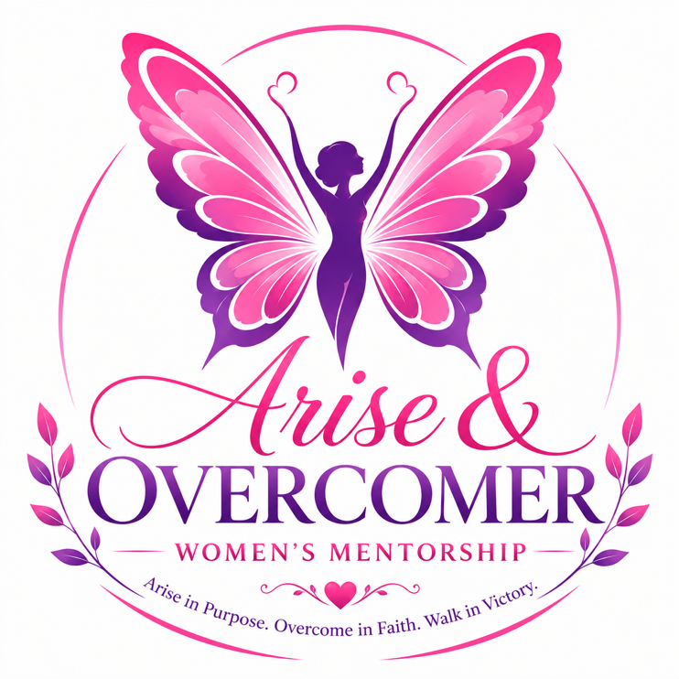
ARISE & OVERCOMER WOMEN’S MENTORSHIP AGREEMENT & CONTRACT
Program Name: Arise & Overcomer Women’s Mentorship
Theme: Her Voice. Her Vision. Her Victory.
Program Director: Dr. Sheritha Sherman

PARTICIPANT INFORMATION
Name: _______________________________________
Address: _____________________________________
Phone Number: _______________________________
Email Address: _______________________________
Date: _______________________________________

PURPOSE OF AGREEMENT
This agreement establishes the expectations, responsibilities, and commitment between the participant and the Arise & Overcomer Women’s Mentorship Program. The purpose of this mentorship is to encourage personal, spiritual, professional, and leadership growth while fostering a supportive community of women committed to walking in purpose and victory.

PARTICIPANT COMMITMENT
As a participant in the Arise & Overcomer Women’s Mentorship Program, I agree to:

1. Attendance & Participation
- Attend scheduled mentorship sessions, workshops, and events.
- Notify leadership if unable to attend a scheduled meeting.
- Participate actively and respectfully in discussions and activities.

2. Confidentiality
- Respect the privacy of all participants.
- Keep personal information and discussions shared within the mentorship confidential unless disclosure is required for safety or legal reasons.

3. Respect & Professional Conduct
- Treat mentors and fellow participants with dignity, kindness, and respect.
- Avoid gossip, bullying, harassment, discrimination, or disruptive behavior.
- Maintain a positive and encouraging atmosphere.

4. Personal Growth & Accountability
- Set personal and professional goals.
- Remain open to constructive feedback and coaching.
- Take responsibility for personal growth and development.

5. Commitment to Integrity
- Demonstrate honesty and ethical conduct.
- Represent the values of Arise & Overcomer Women’s Mentorship positively within the community.

MENTORSHIP EXPECTATIONS
Participants understand that mentors:
- Provide guidance, encouragement, and support.
- Share experiences and resources for growth.
- Do not provide legal, medical, financial, or professional counseling services.
- Maintain appropriate professional boundaries.

CODE OF CONDUCT
I agree to:
☐ Encourage and support fellow participants.
☐ Honor confidentiality.
☐ Communicate respectfully.
☐ Embrace diversity and inclusion.
☐ Demonstrate integrity and accountability.
☐ Foster unity, empowerment, and sisterhood.
☐ Conduct myself in a manner consistent with the mission of the mentorship program.

MEDIA RELEASE (OPTIONAL)
I grant permission for Arise & Overcomer Women’s Mentorship and its representatives to use photographs, videos, testimonials, and recordings taken during mentorship activities for promotional, educational, and marketing purposes.
☐ Yes
☐ No
Participant Initials: _______

LIABILITY RELEASE
I acknowledge that my participation in the Arise & Overcomer Women’s Mentorship Program is voluntary. I release and hold harmless Arise & Overcomer Women’s Mentorship, Dr. Sheritha Sherman, mentors, volunteers, and affiliates from any liability arising from participation in program activities, except where prohibited by law.

PARTICIPANT DECLARATION
I have read and understand the terms of this agreement. I agree to abide by the expectations, guidelines, and values of the Arise & Overcomer Women’s Mentorship Program.

Mentorship Declaration
“I commit to arising in purpose, overcoming obstacles through faith, and walking boldly in victory. I will honor my voice, embrace my vision, and pursue my God-given purpose while encouraging other women to do the same.”

SIGNATURES
Participant Signature: _______________________________
Date: ______________________

Mentor Signature: ___________________________________
Date: ______________________

Program Director
Dr. Sheritha Sherman
Arise & Overcomer Women’s Mentorship
Motto: Arise in Purpose. Overcome in Faith. Walk in Victory. 🦋💜💗
Theme: Her Voice. Her Vision. Her Victory. ✨

